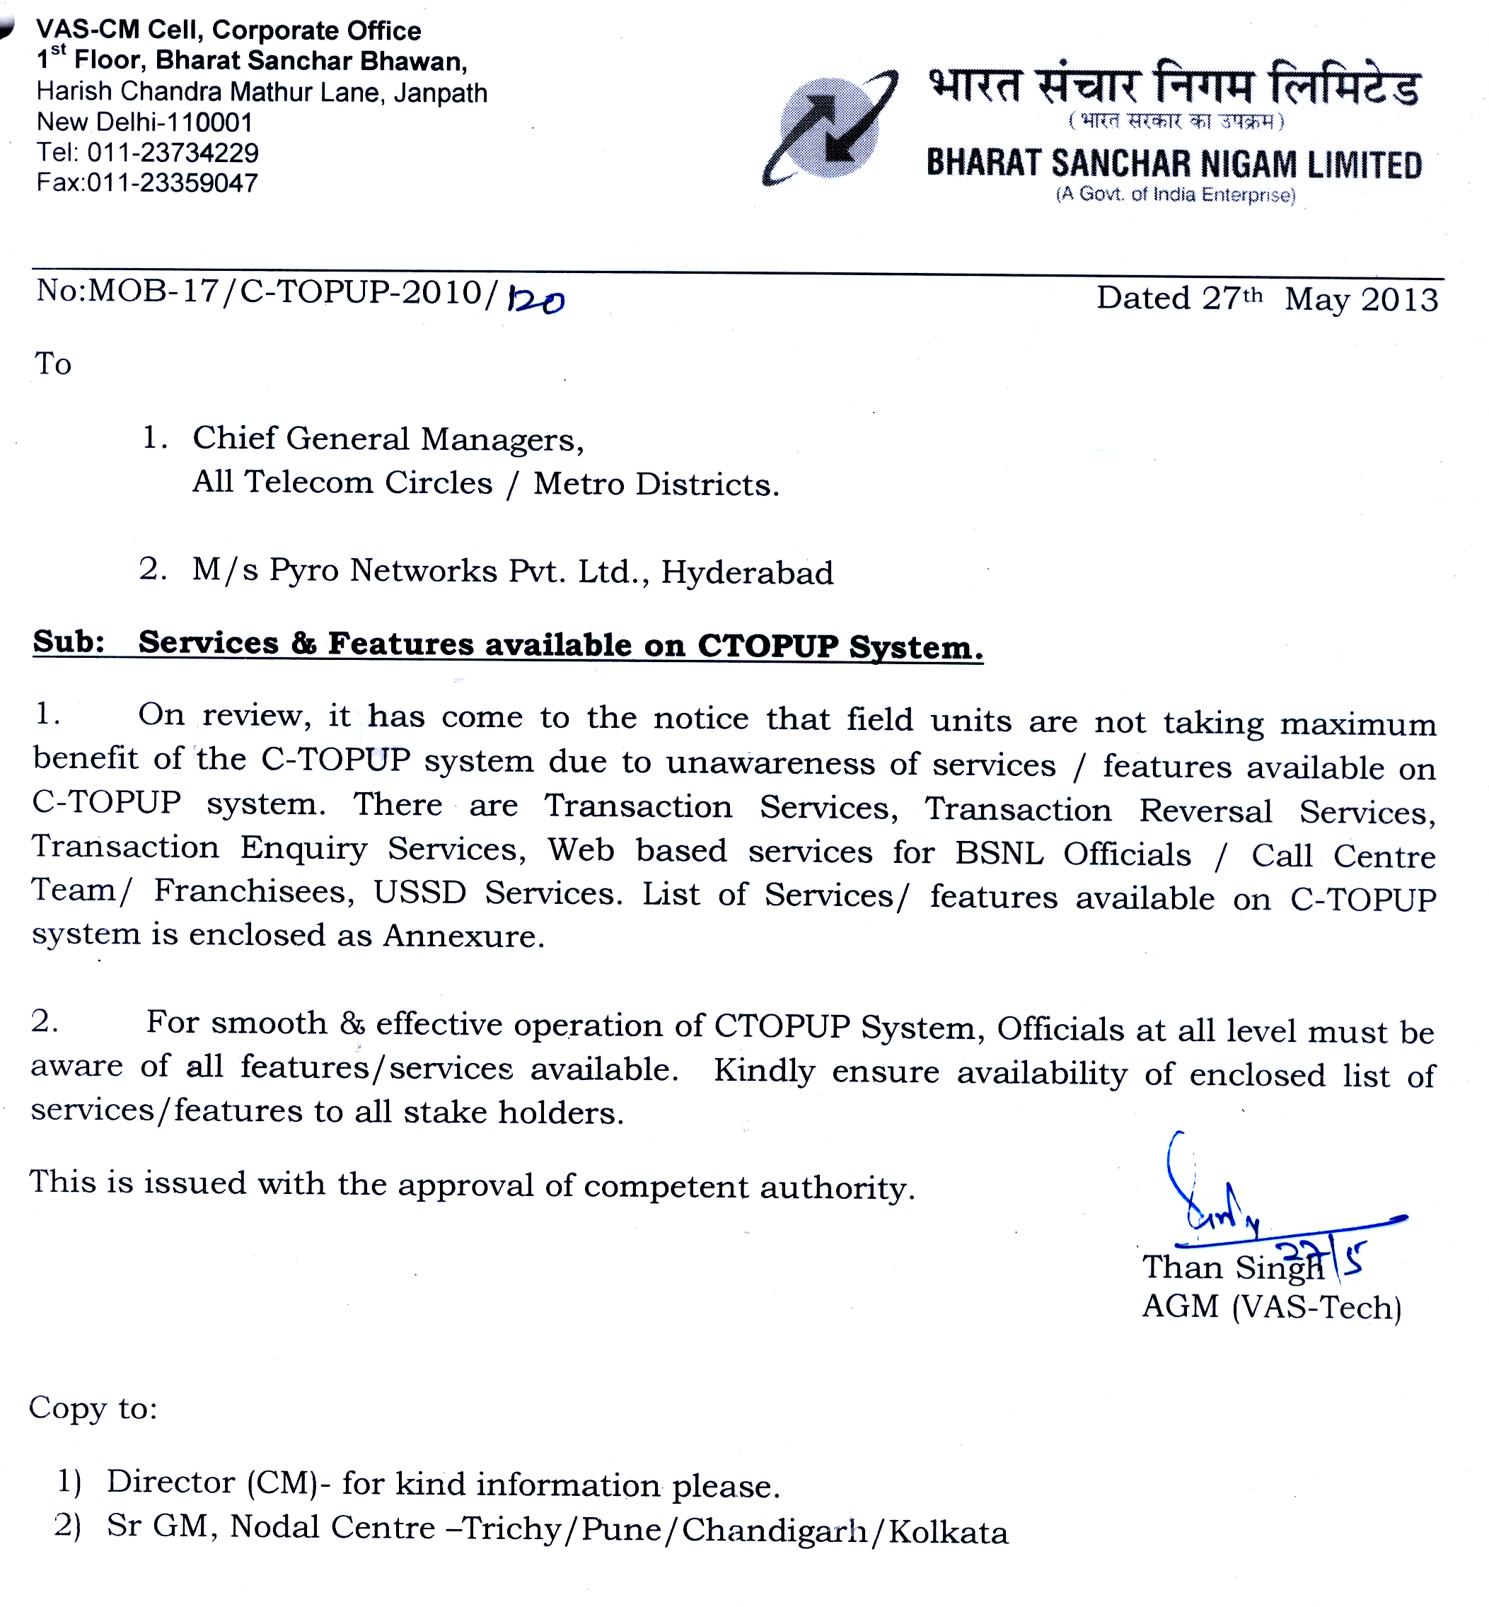

Annexure
Services/Features available on CTOPUP Platform

- Transaction Services
  - Circle specific Recharge, Top Up & Flexi Top Up
  - Roaming transactions
  - E-Distributors/EPIN Vendors
  - Web portal (Integration with ITPC)
  - Postpaid bill payment (GSM & CDMA, Landline under process)
  - VAS Retail (Content sales through retail chain)
  - P2P (Me2U-Gifting of Airtime)
- Transaction Reversal Services
  - Automated reversal of wrong transactions
  - Automated reversal of validity for wrong transactions (only for Ericsson IN)
  - Reversal of wrong stock movements
- Transaction Enquiry
  - Child view
    - Franchisee can check retailers’ available Ctop Up balance by SMS
    - Transaction history-Franchisee/Retailer can check the status of the last 5 transactions by themselves
  - Bill enquiry
    - Franchisee/Retailer can check the outstanding postpaid bill details
  - MPIN reset through IVR (West Zone-Integration with the IVR of the call center)
- Web Based (BSNL Officials)
  - Dealer hierarchy configurations according to categories (Regular, CSC, DSA/PCO, E-Distributor, etc.)
  - Stock allocation & approval
  - Stock allocation & approval cancellations
  - Bulk configuration of dealers (bulk creation of dealers at a particular level by one time upload)
  - Bulk activations / de-activations (change status of multiple dealers from inactive to active and vice versa at a single go)
  - Retailer Bonanza (Upload of additional commission to be passed on to the retailers)
  - CAF Commission module (Upload of CAF commission to be passed on to the franchisees)
- Web Based (BSNL Officials)
  - Dynamic report generation and MIS, to name a few:
    - Daily sales report (Circle/IN/Franchisee wise)
    - Daily stock allocation & approval report (Circle/SSA/Franchisee wise)
    - Denomination wise, Circle wise, SSA wise sales report
    - Transaction Reversal Report
  - Automated Reconciliation Tool
- Web Based (Call Centre Team)
  - Circle wise access given to the call center team
  - Transaction status enquiry
  - Report generation

- Franchisee MIS & Franchisee Mail
  - Reports Available
    - Daily Denomination Wise Sales Summary
    - Daily Stock Summary: Stock Approved & Stock Moved
    - Retailer Wise Sales and Stock Summary
  - FMIS-Reports made available to all the franchisees through public IP URL wherein the stock and sales figures of the franchisee & his retail chain is made available
  - FMAIL-Automated email of the franchisee & his retail chain is sent to the email ids of all the franchisees
  - With these reports, the franchisees can plan their sales and also can view the sales and stock reports of their entire chain of sub-franchisees and retailers

- Database Access (Sancharsoft/FMCC/BSNL)
  - Dealer creation (franchisee & retailer) status
  - Sales Transaction
  - Stock Allocation
  - CAF Commission
  - FRC Commission
  - 3G Services-Access to 3G denominations to facilitate immediate activations
- Various Commission Modules
  - Automated Stock Commission for each category (Franchisees/EPIN/DSA/PCO, etc.)
  - Automated FRC Commission (Franchisees/Retailers)
  - Bulk upload of CAF Commission (Franchisee)
  - Bulk upload of Retailer Bonanza Commission (Franchisees/Retailers)
- USSD Services
  - Prepaid Transactions (As available in SIM’s)
  - Postpaid Bill Collections (GSM & CDMA)
  - VAS Retail (Sale of content through retail chain)

